* Please make heading section as below picture,

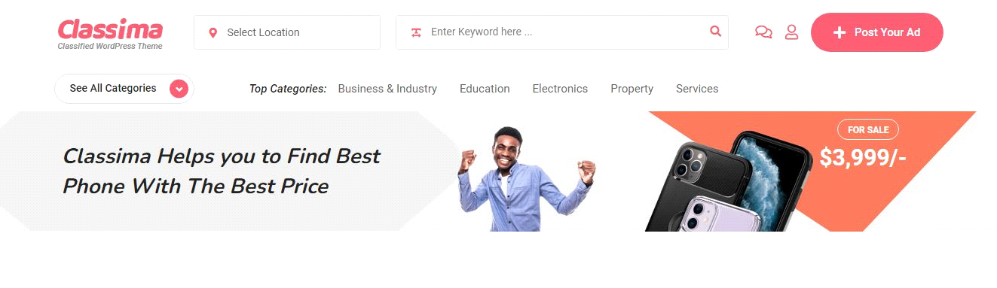

* How to add advertisement section like this in classima ( if someone want make add on website they can pay and add)

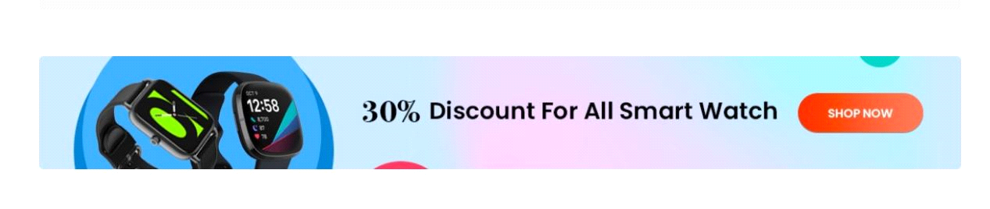

Please make category in home as <https://bikroy.com/> , I cone I will arrange and change heading and ads number and pattern make as same,

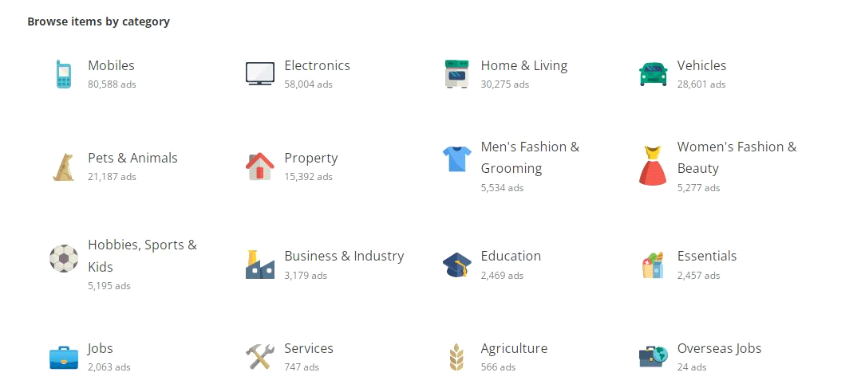

* As we discussed my website will have all categories and sub categories of <https://bikroy.com/>
* As we discussed and agreed there should separate page for resume posting, so please make as homage as <https://bikroy.com/>, so please add this section as it is.

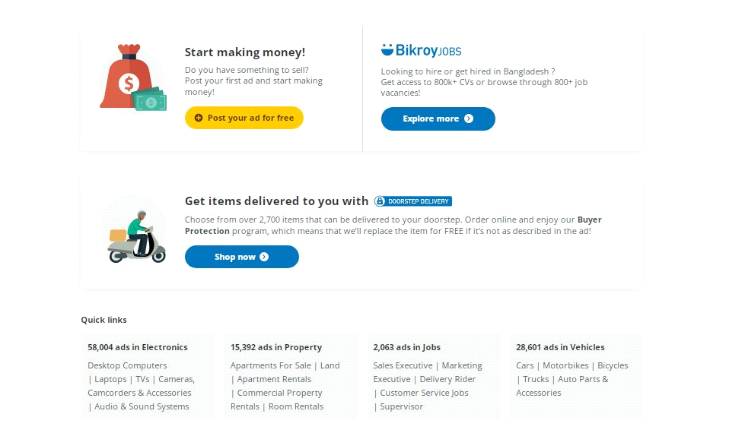

Make home page as it is, it is very professional.

* Please ad this app section above footer.

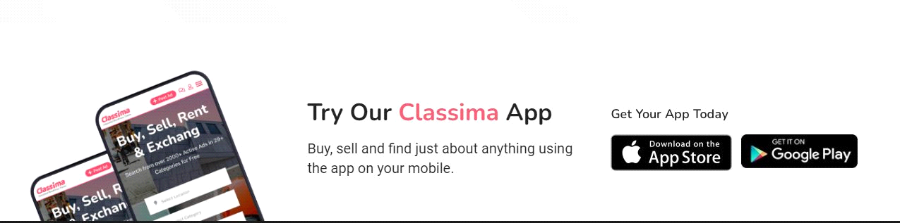

* Please make footer as below, instead of app details, please add news letter & social icon.

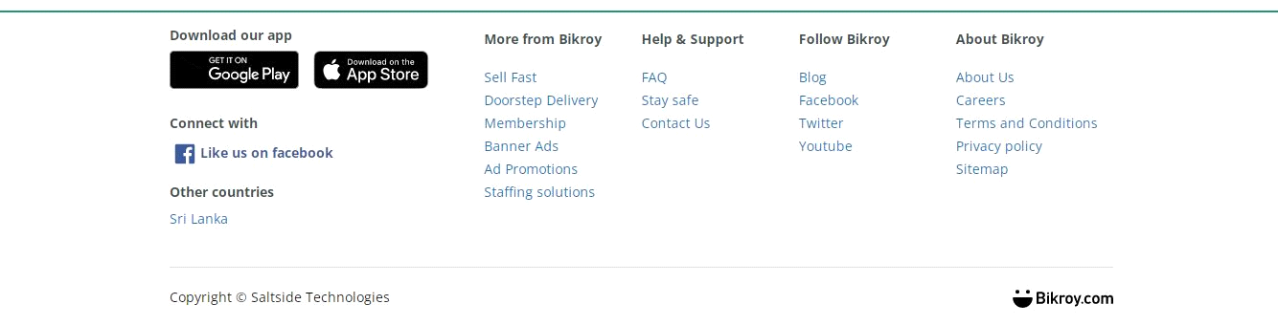

* Can I add popular / featured items in home page like below picture (category wise), please guide me how.

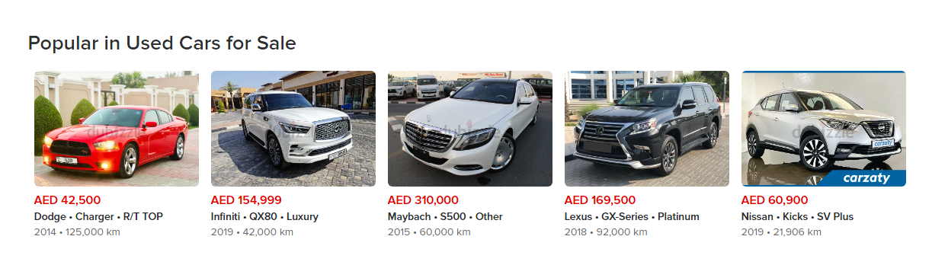

* While posting ads Please make option to pick default features in website, like below picture. ( Admin has to provide all features and customer can select just by clicking, no need to type)

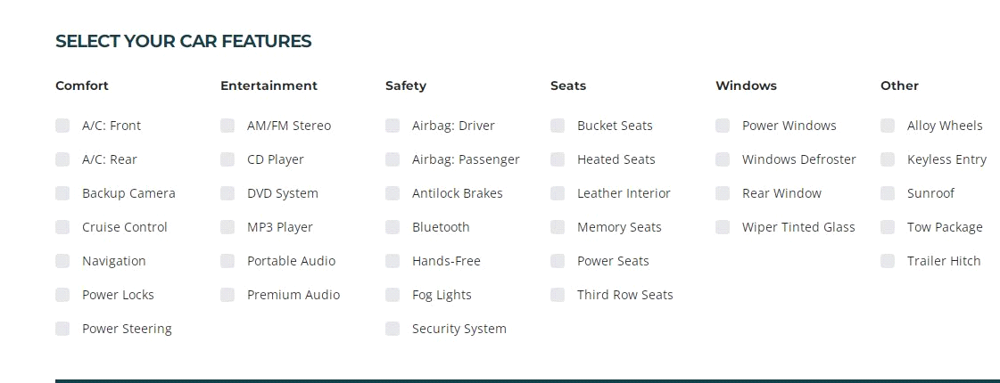

Let existing features option there as additional features, so that customer can add more info other than admin provided in selection.

* I don’t find live chat option between customers which is like in Classima theme.
* Please make option for seller can restrict their information from public
* What about mobile verification option while creating account?
* I don’t find following features, hope you working on those.
* Social login
* Report Abuse
* Quick view
* Mark as Sold
* Live chat
* Google re-captche
* Customer should not be able to post ads until email & mobile number verified & add will approve by admin for any customer.
* Please display verified icon for next to seller name in all ads and seller page like below picture(so that customer can earn more trust on seller )

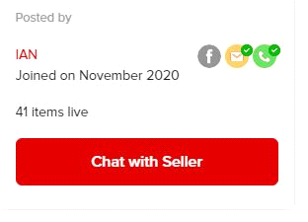

* As we discussed there should be option for water mark ( when admin approve ads, water mark will appear in all customer uploaded picture)
* How to add more option in side bar? Like below **( including Filters ads by)**

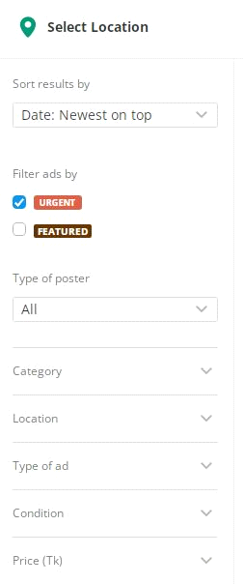

**Mobile View - Please make mobile view as** [**https://bikroy.com/**](https://bikroy.com/) **looks like in mobile.**

1. Location setup
2. Select2 not working on listing page
3. Features ads section check
4. Mobile header menu
5. Post ads link 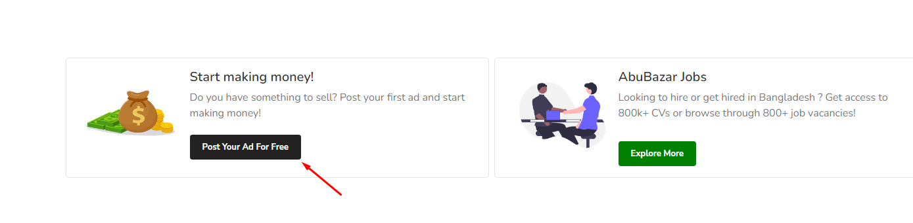
6. Job category ads posting
7. Jobs page ar title color change
8. Home page ads sorting check
9. Need to take confirmation from user to show personal info on ads details page
10. Social login
11. Report Abuse
12. Google re-captche
13. Email verification to mail
14. Please display verified icon for next to seller name in all ads and seller page like below picture(so that customer can earn more trust on seller ) 
15. Water mark for images
16. Admin panel a system update korle success msg show kore na
17. Admin ar cms menu error
18. Ads counter
19. Ads details page a error
20. 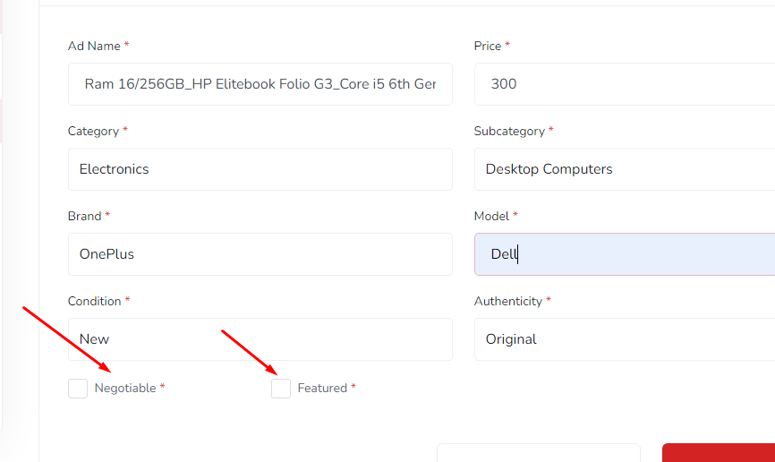optional hobe
21. Ads image single and multiple check
22. Ads posting is not working
23. Ads edit and update is not working